# StraightTalk Basic Customer Support Chatbot

Working Examples from Different scenarios

## Basic testing

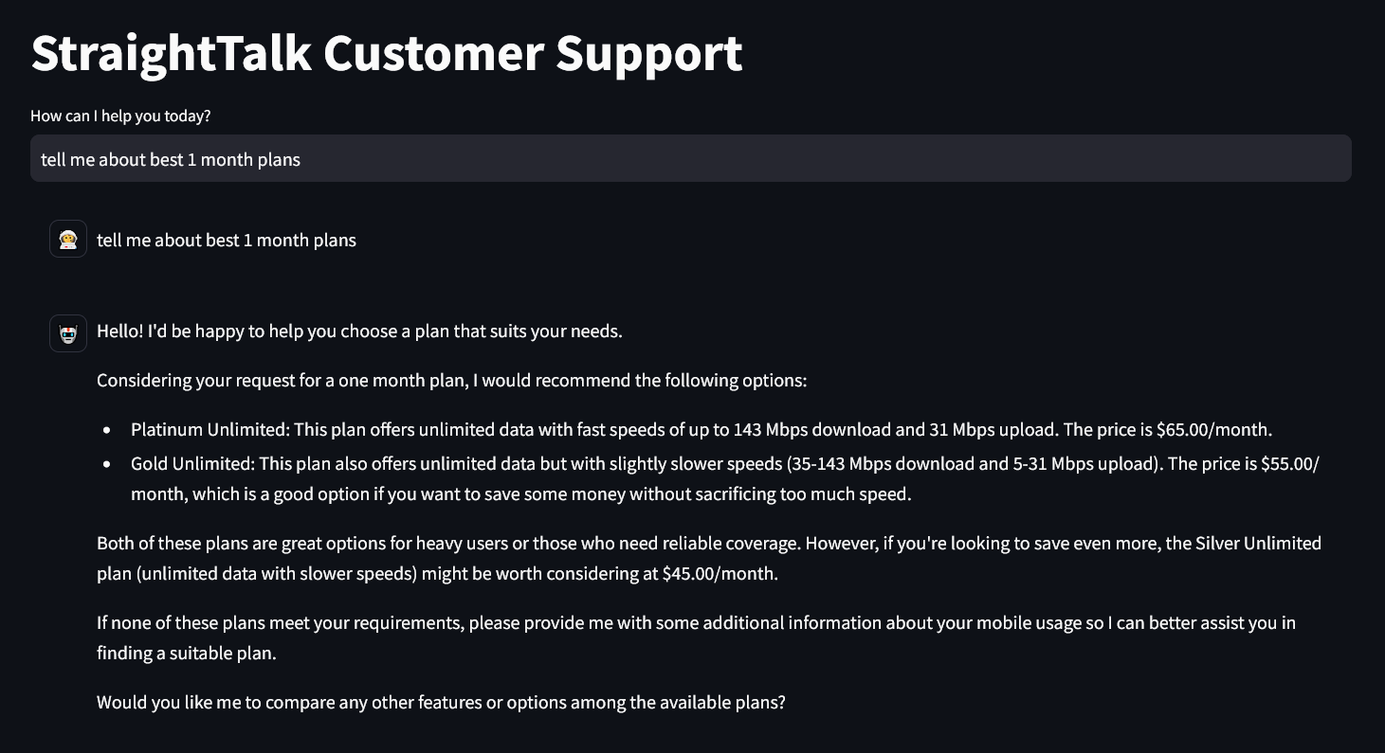

## Scenario 1:

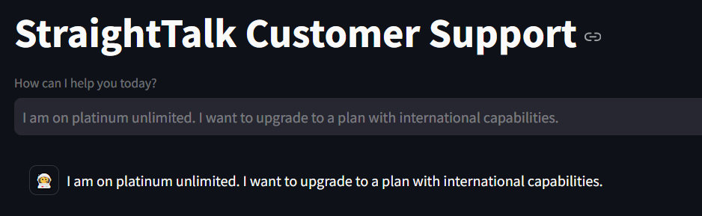

### Reasoning Process Documentation - terminal output

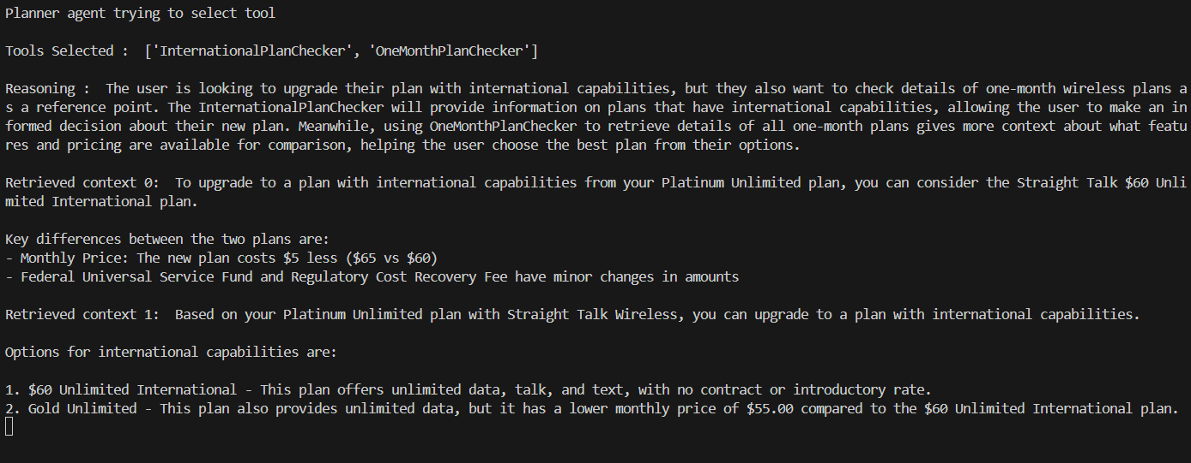

### Terminal output - General text for easy readability:

Planner agent trying to select tool

Tools Selected : ['InternationalPlanChecker', 'OneMonthPlanChecker']

Reasoning : The user is looking to upgrade their plan with international capabilities, but they also want to check details of one-month wireless plans as a reference point. The InternationalPlanChecker will provide information on plans that have international capabilities, allowing the user to make an informed decision about their new plan. Meanwhile, using OneMonthPlanChecker to retrieve details of all one-month plans gives more context about what features and pricing are available for comparison, helping the user choose the best plan from their options.

Retrieved context 0: To upgrade to a plan with international capabilities from your Platinum Unlimited plan, you can consider the Straight Talk $60 Unlimited International plan.

Key differences between the two plans are:

- Monthly Price: The new plan costs $5 less ($65 vs $60)

- Federal Universal Service Fund and Regulatory Cost Recovery Fee have minor changes in amounts

Retrieved context 1: Based on your Platinum Unlimited plan with Straight Talk Wireless, you can upgrade to a plan with international capabilities.

Options for international capabilities are:

1. $60 Unlimited International - This plan offers unlimited data, talk, and text, with no contract or introductory rate.

2. Gold Unlimited - This plan also provides unlimited data, but it has a lower monthly price of $55.00 compared to the $60 Unlimited International plan.

### Final Response

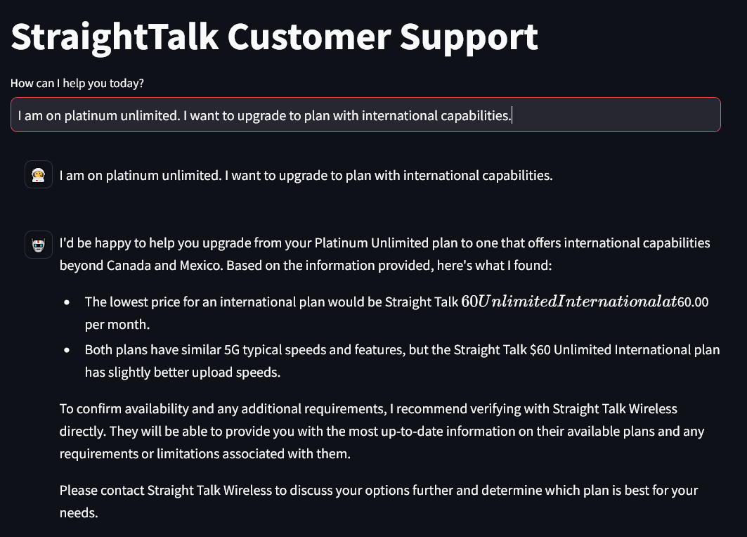

## Scenario 2:

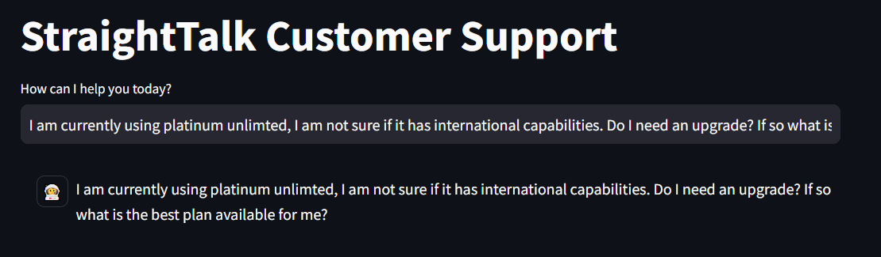

### Reasoning Process Documentation - terminal output

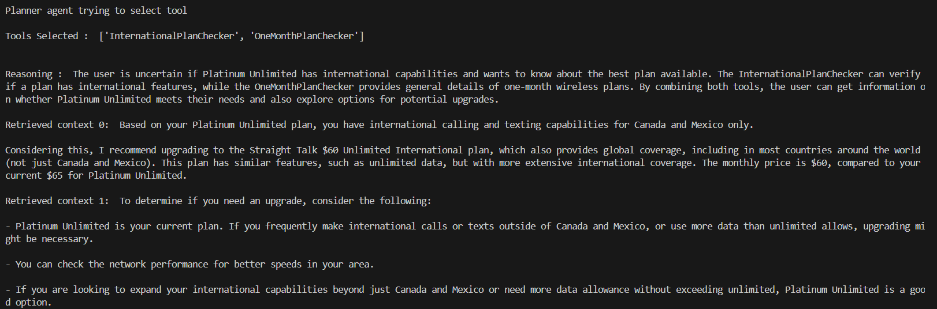

### Terminal output - General text for easy readability:

Planner agent trying to select tool

Tools Selected : ['InternationalPlanChecker', 'OneMonthPlanChecker']

Reasoning : The user is uncertain if Platinum Unlimited has international capabilities and wants to know about the best plan available. The InternationalPlanChecker can verify if a plan has international features, while the OneMonthPlanChecker provides general details of one-month wireless plans. By combining both tools, the user can get information on whether Platinum Unlimited meets their needs and also explore options for potential upgrades.

Retrieved context 0: Based on your Platinum Unlimited plan, you have international calling and texting capabilities for Canada and Mexico only.

Considering this, I recommend upgrading to the Straight Talk $60 Unlimited International plan, which also provides global coverage, including in most countries around the world (not just Canada and Mexico). This plan has similar features, such as unlimited data, but with more extensive international coverage. The monthly price is $60, compared to your current $65 for Platinum Unlimited.

Retrieved context 1: To determine if you need an upgrade, consider the following:

- Platinum Unlimited is your current plan. If you frequently make international calls or texts outside of Canada and Mexico, or use more data than unlimited allows, upgrading might be necessary.

- You can check the network performance for better speeds in your area.

- If you are looking to expand your international capabilities beyond just Canada and Mexico or need more data allowance without exceeding unlimited, Platinum Unlimited is a good option.

### Final Response:

